Ideation Phase
Define the Problem Statements
Date | 21 September 2026
Team ID | SWTID-2026-8948
Project Name | AI FAQ Assistant
Maximum Marks | 2 Marks

Customer Problem Statement
The Customer Problem Statement phase focuses on understanding the problems faced by users and support teams while managing frequently asked questions. The team identified the difficulties involved in creating and updating FAQs, finding relevant information quickly, managing FAQ data securely, and preparing accurate answers for repetitive customer queries.
By understanding these problems from the customer's point of view, the team was able to identify the major challenges and define the requirements for the proposed AI FAQ Assistant. The following problem statements summarize the key difficulties identified during the analysis.
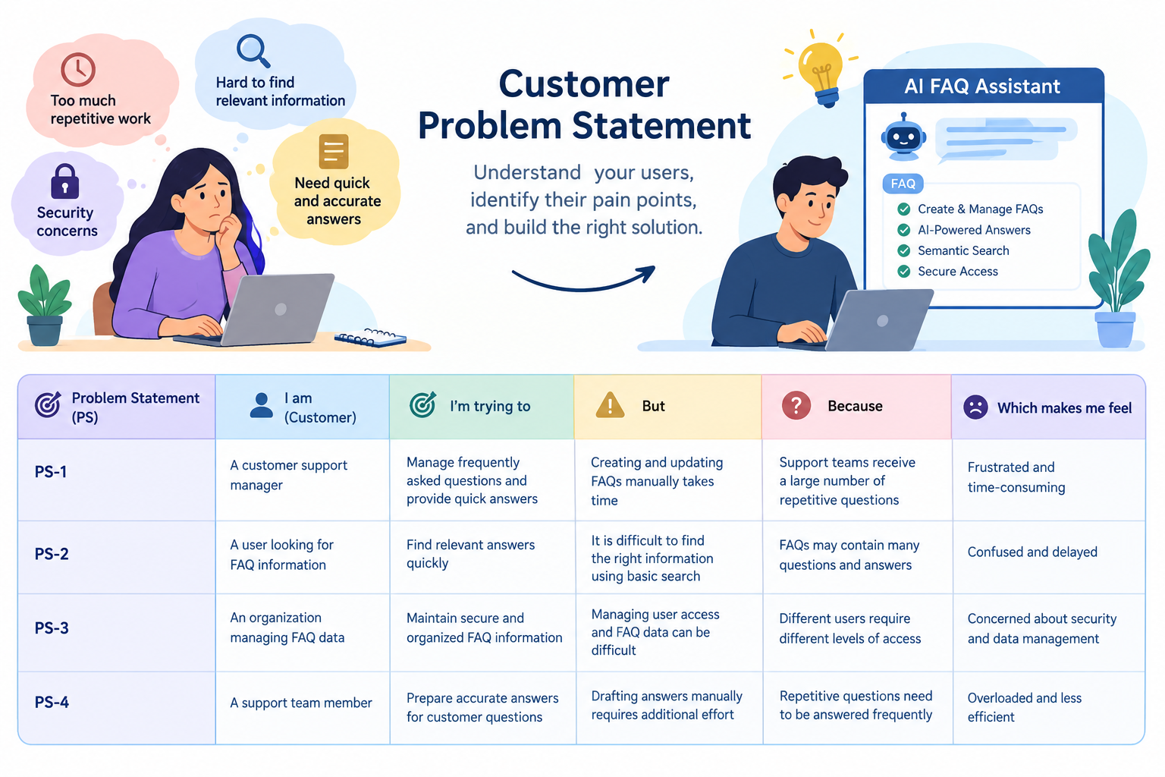

Problem Statement (PS) | I am (Customer) | I’m trying to | But | Because | Which makes me feel
PS-1 | A customer support manager | Manage frequently asked questions and provide quick answers | Creating and updating FAQs manually takes time | Support teams receive a large number of repetitive questions | Frustrated and time-consuming
PS-2 | A user looking for FAQ information | Find relevant answers quickly | It is difficult to find the right information using basic search | FAQs may contain many questions and answers | Confused and delayed
PS-3 | An organization managing FAQ data | Maintain secure and organized FAQ information | Managing user access and FAQ data can be difficult | Different users require different levels of access | Concerned about security and data management
PS-4 | A support team member | Prepare accurate answers for customer questions | Drafting answers manually requires additional effort | Repetitive questions need to be answered frequently | Overloaded and less efficient

